Field Trip Activities on Lamma Island
Set 2

Name: ___________________ ( ) | S. _______ | Date: _______________
Stop 1 Yung Shue Wan Main Street
Part 1 Rubbish – what’s the solution?
- What sustainable method is used to deal with waste in Yung Shue Wan?

- List three benefits of using the method mentioned in Question 1.

- Work in groups and walk along the main street. Find out the collection points for recyclable materials. On the map below (Figure 1), mark and label the area where they are for each of the following products with corresponding letters.
- Paper (b) Plastics (c) Metal s (d) Glass bottles
(e) Rechargeable batteries (f) Clothes (g) Small electrical appliances
Figure 1
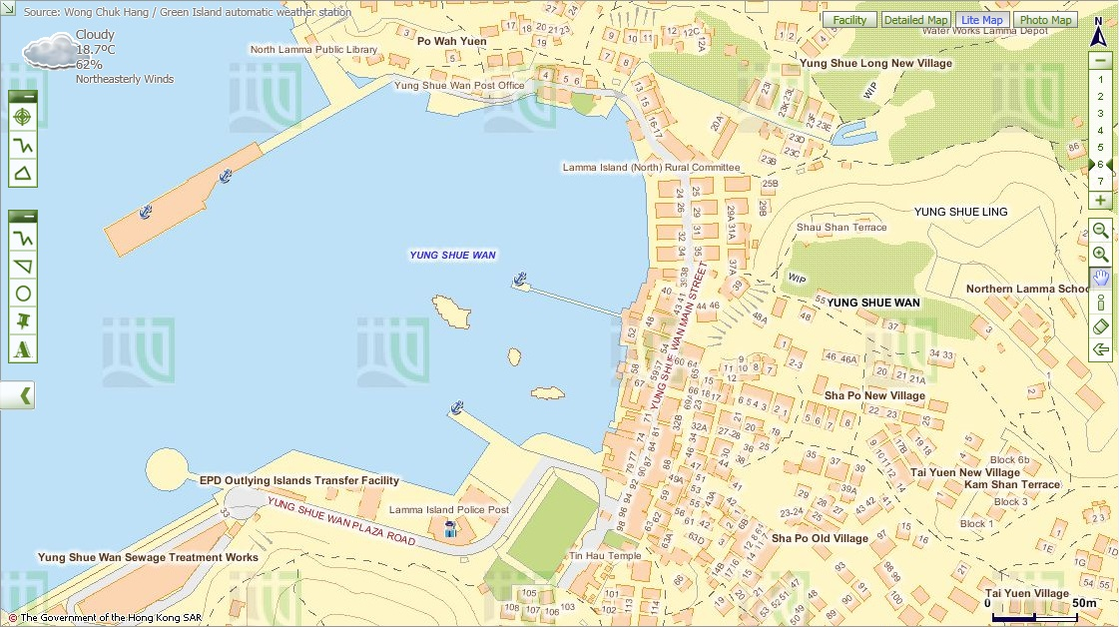
Police
Post
Map from Lands Department

4. Discuss with your group members whether the waste separation and recycling scheme is successful. Give evidence to support your answer.

5. Suggest two ways to improve the scheme so that more people, including visitors use it more often.

6. Compare the collection points for recyclable materials in Yung Shue Wan Street with those near your school or living area.

Part 2 Closed loop recycling – what is it?
Visit ‘Lamma Corner’.
- Through observations and interview, what are the differences between Lamma Corner and other shops in your living area in terms of the products sold? Give evidence to support your answer.

2. The closed loop recycling is practised on Lamma Island.
Pre-trip Task:
Search for information on closed loop recycling. Draw the logo below and explain the three processes involved.

(a) How can this closed loop recycling help combat climate change?

- Do you think that all recyclable materials collected can enter the loop of recycling? Why?

Taking into consideration of your answers in (a) and (b), do you think
recycling is a good way to combat climate change? What else can we
do to combat climate change?
- Do you think all the recyclable materials are recycled locally in Hong Kong? Why?

3. Do you think recycling is a good way to combat climate change? Why? What else can we do to combat climate change?

Part 3 Eco shopping
Work in groups and walk along the street.
- Go to one of the green shops and select two types of packaged food that you think they are environmental-friendly. Complete the following table based on the information on their labels.
 | Food A | Food B
- Name of food
- Is the food homemade? If not, where is it produced? | Yes No  If no,  Hong Kong  The Mainland  Other countries | Yes No  If no,  Hong Kong  The Mainland  Other countries
- Is the food made from organic farms?
- Number of ingredients
- Do the ingredients come from plants or animals? Give two examples. | Plants Animals  Both  Examples:  _____________________  _____________________ | Plants Animals  Both  Examples:  _____________________  _____________________
- What is/are the packaging material(s)? | plastic bag  paper  others _____________ | plastic bag  paper  others: _____________

2. Which food would you like to buy in order to reduce more carbon emission? Give three reasons to support your answers.

3. After this activity, will you change your shopping habits? Why?

Stop 2 A Local Farm
- Work in groups. Observe the operation of this farm and interview the farmer. Complete the following table.

Questions | Answers
- How to improve soil  quality? | using chemical fertiliser  using compost  covering soil with mulches  crop rotation  fallowing  agroforestry: trees are grown with crops  others _______________________
(b) How to avoid pest? | using chemical pesticide  using CD-ROMs  using plastic balls  growing different types of crops  crop rotation  growing companion crops  using insect trap  others _______________________
(c) How to use water resource? | constructing wells  building water tanks or ponds  covering soil with organic matter  using drip irrigation  others _______________________
- What tools are used for farming? | using simple tools, e.g. ___________  using machines, e.g. ___________
(e) What is the useful output? | crops, e.g. _____________________  animal products, e.g. ___________

2. Do you think this way of operation of farm can reduce carbon emissions? Give reasons.

 | Can it help to reduce carbon emission? Put ‘’ or ‘’ | If yes, how can this help to reduce carbon emission?
- Way of improving soil quality
- Way of avoiding pest
- Way of using water resource
- Tools used for farming
- Type of output

- Would you like to buy agricultural produce grown in this type of farm for reducing climate change? Give reasons to support your answers.

Stop 3 Viewing at Lamma Power Station

Pre-trip Task:
Write the letters in the space provided to show the components of power station in Figure 2. You may browse the following website to complete this task.
The Power behind Hong Kong--Lamma Power Station:
Source: HK Electric
https://www.hkelectric.com/en/MediaResources/Documents/LPS_2014.pdf

- Coal-fired Generating Units | - Gas-fired Combined-cycle Generating Units | - Oil-fired Generating Units
- Coal Yard | - Ash Lagoon | - Transport jetty

Figure 2 Components of Power Station
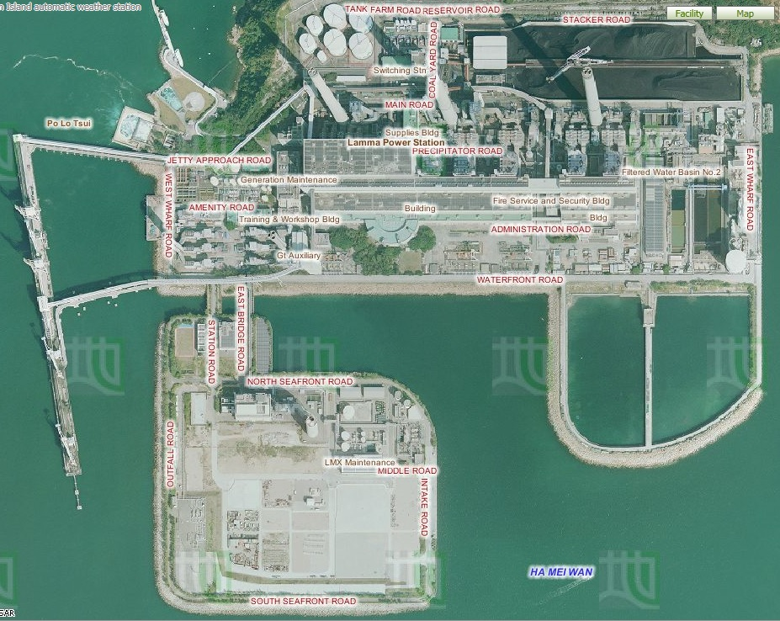
1.
3.
2.
4.
6.
5.
Lamma Power Station Extension

Aerial Photos from Lands Department

- Observe the power station. Describe and explain the locational advantages of the power station.
Locational characteristics | Reasons

- Figure 3 shows the amount of air pollutants emitted from coal-fired and gas-fired generating units respectively when the total electricity generation in the year 2012 would increase by 2.57 times compared with that in 1990.
Figure 3 Amount of Air Pollutants Emitted from the Coal-fired and Gas-fired Units

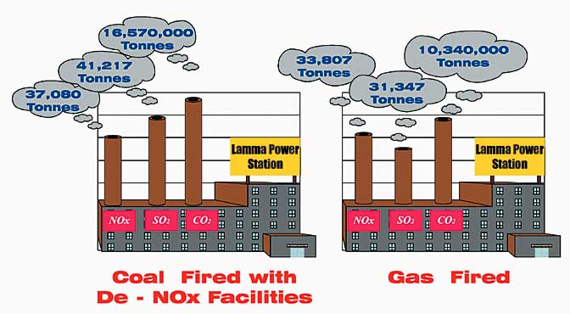

Source: Environmental Protection Department, HKSAR Government
http://www.epd.gov.hk/eia/operation/english/chapter05_4.html
- How does the power station affect our environment?

- More generating units will be built to generate more electricity in future. Explain why.

- Which kind of fossil fuels should be more widely used in the new generating units? Explain why.

- Do you think that using a mixture of different types of fossil fuels only can help minimise climate change in future? Why?

Stop 4 Lamma Winds

Part 1 Is the use of renewable energy a way out in Hong Kong?
Pre-trip Task:
Collect the following data at night from the website of HK Electric below before the field trip:
Source: HK Electric
https://www.hkelectric.com/en/our-operations/lamma-wind-power-station/real-time-
operation

 | Before the field trip  (collect from website after 9:30 pm) | During the field trip  (collect at Lamma Winds)
Date & time
Present wind speed | m/s | m/s
Present power output | kW | kW
Cumulative electricity generated | kWh | MWh
Amount of carbon dioxide (CO)₂ saved | kg | tonnes
Remarks: The units of cumulative electricity generated and amount of carbon dioxide saved shown on HK Electric’s website are different from those shown at the tower base of the wind turbine.
1.(a) Collect the data at the tower base of the wind turbine and complete the above table.
(b) What is the relationship between wind speed and power output?

(c) Explain why this wind turbine cannot be designed to produce a lot of electricity.

(d) By observation, list the environmental problem(s) caused by the wind turbine.

2. Table 4 shows the capacity of the Lamma Power Station.
Table 4 Capacity of the Lamma Power Station in 2013

 | Number of units | Capacity of each unit (MW) | Total capacity (MW)
Coal-fired Generating units | 3 | 250 | 750
 | 5 | 350 | 1750
Oil-fired Generating Units | 4 | 125 | 500
 | 1 | 55 | 55
Gas-fired Combined-cycle Generating Units | 1 | 335 | 335
 | 1 | 345 | 345
Solar Power System |  |  | 1
Lamma Winds |  |  | 0.8
Total |  |  | 3736.8
Source: HK Electric
https://www.hkelectric.com/en/MediaResources/Documents/LPS_2014.pdf
(a) Compare the capacity of electricity generated by fossil fuels and renewable energy.

(b) What are the limitations of developing renewable energy in Hong Kong?
Limitations | Explanation
Cost
Space
Stability of power generation
Amount of power generated
Others

3. Should different types of renewable energy, particularly solar energy and wind energy, be further developed in Hong Kong?
Each group will be assigned one of the following roles. Study the exhibition board and collect the information from the exhibition panels for discussion.

Role | Tasks
Government | Discuss why different types of renewable energy should be further developed in relation to existing environmental problems
Spokesman from a power company | Discuss whether the development of different types of renewable energy is cost-effective
Environmentalist | Discuss the negative impact of the development of different types of renewable energy on the environment
Urban planner | Discuss the problems in the selection of suitable sites for the development of different types of renewable energy
Spokesman from Department of energy | Discuss whether different types of renewable energy can give abundant and reliable energy supply in Hong Kong and their energy efficiency
Your role:
Your opinion:

4. The use of technical measures, like fuel mix and renewable energy, seems not to be the most sustainable way to combat climate change caused by power station. Then what else can we do to solve this problem? Suggest two ways and explain your reasons.

Part 2 Putting ‘waste’ into use

1. (a) What material is used to make the bricks in the footpath? Where does this material come from?

(b) How can this way of using this material reduce carbon emission?

Stop 5 Hung Shing Yeh Beach Tree Planting Site
- Read the information from the interpretive plate. What are the two types of trees? Give one example of each type of trees.
Type | Example

2. How can the planting of trees help reduce climate change?

3. Figure 5 shows the carbon cycle. Study the figure and answer the question.

Figure 5 Carbon Cycle
Remarks: It is a simplified version of the carbon cycle. The figures are in gigatonnes
(1000 million tonnes). The figures in black are estimates of the total mass of carbon (worldwide) in the different spheres. The figures in red are the estimated flows of carbon between spheres.
Source: Climate Change - A Cross-curricular Learning and Teaching Resources Pack, Education Bureau

(a) How do human activities affect the balance of carbon dioxide in the air?

(b) Apart from planting of trees, what else can we do to help reduce climate change? Suggest two methods.

Stop 6 The Home Farm

At Lo So Shing Village, observe the activity held outside the village houses.
- What agricultural produce is grown from the farm?

- Do you think that the produce is for self-consumption only? Give reason to support your answer.

- How can the growing of our own food help reduce carbon emission in Hong Kong?

- Could you grow your own food at home? Why or why not?

- What else can we do for food supply to reduce climate change?

Stop 7 Mudflat

- What are the characteristics of mudflat?
- What is its relief?
- What is made up of the mudflat?
- Does the depth of water vary from time to time?

- What kinds of living organisms live in the mudflat?
Examples
Plants
Wetland Animals
- What does Mudflat provide for these living organisms?

- How will climate change affect the living organisms in the mudflat?

5. What should you do to protect these living organisms in our daily life?

Discussion
Discuss the following questions with your group members.

1. What are the new opportunities of climate change?

2. “We do not have to combat climate change as the nature is able to resume equilibrium itself”. Do you agree? Why?

